ROHIT KUMAR 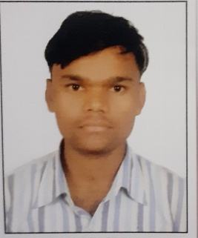

DOB-15/08/1998
Village and Post: Jatpurwa, Dist.-Lakhimpur kheri ,State Uttarpradesh
Phone: 7007103432
E-mail:kumarohit264@gmail.com

- Objectives
To work on a challenging job profile which provide an opportunity to enhance my technical skill and knowledge, this could provide me an insight into new aspects so that it would be helpful for my career.
- PERSONEL DATA
NAME : ROHIT KUMAR
FATHER NAME: MR. CHUNNA LAL
MOTHER NAME: MRS. SUNEETA DEVI
AGE: 22
SEX: MALE
MRITAL STATUS :UNMARRIED
NATIONALLITY; INDIAN
LANGUAGE- HINDI, ENGLISH
- Eductions
- 10th –ZPIC INTER COLLEGE (UP BOARD), MAY-2014
- Mark Percentage:72.83%
- 12^{th SCIENCE} STREEM –DS INTER COLLEGE LAKHIMPUR KHERI, MAY 2016
- Mark Percentage:60.10%
- BACHELOR OF ARTS-CHHATRAPATI SHAHU JI MAHARAJ UNIVERSITY KANPUR, MAY 2019
- TECHNICAL QUALIFICATIONS- ITI- GOVERNMENT INDUSTRIALTRAINING
INSTITUTE NIGHASAN, LAKHIMPUR KHERI [UP]
- TRADE- ELECTRICIAN
- Mark Percentage:82.25
- EXPERRINCE: AGILE AIRPORT SERVICE PVT LDT[1 JULY2019 TO 31 AUGUST 2020

- Resume: ROHIT
- TATA MOTORS ] 1 JUNE2018 TO 30 JUNE2019
- MILLENNIUM AERO DYNAMICE PRIVATE LIMITED-1-DEC TO 6 APRIL 2022
- YEAR:3 YEARS
•Skills
- COMPUTER AND EXCLE KNOWLEDGE
- ELECTRICAL KNOWLEDGE
- TRAINING-
- BHARAT SCOUT GUIDE IN ZPIC INTER COLLEGE JATPURWA, LAKHIMPUR KHERI
S
S | STRENTH  - Work with positive attitude to contribute healthy functioning of the organization.  - Self-confident and great patients.  - Analyzing every angle of project before working on it.  - Willingness to learn.  - Adaptability to change the environment.

- Page 2 | [Type your phone number]

