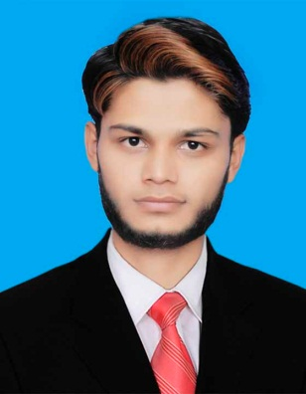
Name:GHULAM MURTAZA
Address:KHARA ROAD CHUNGI KASUR

OBJECTIVE

Wish to join an organization that can recognize my potential and provide me with the necessary training and expertise to help me progress further in my concerned field as well as help in building my confidence to pace with this innovative and challenging commercial world.

PERSONAL PROFILE

- Father’s Name ; Mushtaq Ahmad
- Religion ; Islam
- Date of Birth :31-07-1998
- Nationality : Pakistan.
- Marital Status : Single
- N.I.C.No. : 35102-3033180-1
- Gender : Male.
- Cell :0306-6566533
EDUCATIONAL QUALIFICATION

- Matric
- DAE Mechanical (Auto&Diesel)
Experience
- 2 year internship in bully shah auto care center (KASUR)
- 1 year experience in ms office, would, power point
- 2 years experience in PIA (Pakistan international airlines)

REFERENCES
- Will be provided on request

