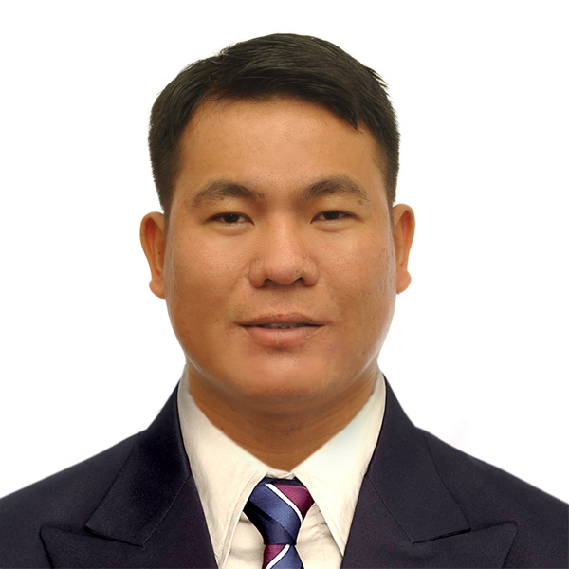oto

Ricky Baraquio Caburnay
Position : GSE Diesel Technician
Mobile : 0210456837
Email : rickycaburnay1988@yahoo.com
PROFILE SUMMARY

- Total years of experience - GSE – 12 years and 3 years Hyundai car dealership
  - Engine
  - Under carriage
  - Hydraulic
  - Gearbox
  - Power train
  - Electrical skills
- Overhauling experience
  - Engine
  - Hydraulic Pump
  - Control Valve
  - Gearbox
  - Differential
- Diagnostic Tools used
- Work exposure:
  - Field Service (total years of experience) 15 years
  - Workshop (total years of experience) 15 years
- Educational attainment
- Bachelor of Industrial Technology Major in Automotive Technology
PROFESSIONAL EXPERIENCE
Date Start : June 2020 up to present
Position : Ground Support Equipment Diesel Technician
Company Name : Babcock International Group (Base Air New Zealand)
Location : Queens Parade (Naval Base), Base Devonport Auckland 0624
Department : Ground Support Equipment Maintenance

Date Start : November 2019 - June 2020
Position : Tyres Fitting
Company Name : Cheap Tyres
Location : Sales yard Road Otahuhu
Department : Tyres Fittings Workshop

Date Start : April 17, 2014 – November 2019
Position : Ground Support Equipment Mechanic
Company Name : Certis Cisco Deployment Singapore Airlines
Location : 34 Changi N Cres, Singapore 499614
Department : SIA Engineering Equipment Maintenance
Company Profile : Don’t break the egg / Zero Accident
Company Website : www.aji.com.sg

Date Start : 1 December 2011 – 1 December 2013
Position : Ground Support Equipment Mechanic
Company Name : Saudi Arabian Airlines Engineering Company
Location : Prince Mohammed Bin Abdul Aziz Intl. Airport, Medina KSA
Department : Ground Support Equipment Maintenance
Company Profile : Discover the High Light
Company Website : www.saudiags.com
Reason for leaving : End of contract

Date Start : April 2009 – November 2011
Position : Auto. Technician
Company Name : Hyundai Binan Laguna
Location : National Highway Binan, 4024 Laguna, Philippines
Department : Auto Service Centre Car Dealership

Duties and Responsibilities
- Always safety
- Maintain cleanliness workplace
- Maintain cleanliness tools
- Maintain cleanliness car service
- Work as team

Field Service experience
- Disconnect the equipment under the aircraft
- Daily Checking Equipment Tarmac
- Steering error
- Replaced hydraulic hoses / oil leak
- Replaced axle
- Replaced tire puncher
Workshop experience (works performed)
- General servicing engine / transmission / hydraulic system
- Diagnosing
- Replaced engine
- Replaced transmission
- Replaced all hydraulic hoses
- Under wash
Mechanical Repairs (Major and Minor):
- Engine overhauling
- Top overhaul
- Engine tune-up
- Replaced torque converter
- Replaced timing belt / chain / gear
- Replaced crankshaft oil seal
- Replaced water pump
Hydraulic Repairs (Major and Minor):
- Check hydraulic pressure system
- Replaced hydraulic pump
- Replaced hydraulic block
- Replaced solenoid relay
- Replaced wirings
Undercarriage Repair (Major and Minor):
- Replaced steering knuckle
- Replaced leaf spring / rubber dumper
- Replaced deferential
- Replaced Planetary gear
- Replaced rotor discs / brake pads
- Replaced propeller shaft
- Replaced drive shaft /oil seal
Overhauling/Rebuild experience (engine model, components etc):
- TCD 2011 L04 (Deutz)
- BF 4M 2012 (Deutz)
- BF 6M 1013 F (Duetz)
- TCD 2013 L06 (Duetz)
- TCD 2015 V06 (Duetz)
- BF 6M 1015 C (Duetz)
- QSB6.7 240 (Cummins)
Electrical Repairs:
- Starting
- Charging
- Replaced and Install camera, monitor, GPS
- Replaced and Install Wirings
- Replaced and Install ECU,TCU,PLC
Diagnostic Tools/Software used:
- Murphy control
- Battery Analyzer
- Global diagnostic system
Type/Brand/Model of Equipment Serviced:
- Schopf 396P / F300
- TLD Aircraft conventional tractor TMX150-16 /
- TLD Aircraft towbarless tractor TPX-200-MTX
- Kalmar motor AB, TBL190 towbarless towing tractor
- Mototok spacer 8600 MA towbarless / remote control
- Douglas TBL 400 towbarless
- Bliss fox
Duties and Responsibilities
- Always safety
- Maintain cleanliness workplace
- Maintain cleanliness tools
- Maintain cleanliness car service
- Daily Check serviceable unserviceable
- Work as Team
Field Service experience (client/location/works performed)
- Disconnect the equipment under the aircraft
- Daily Checking Equipment Tarmac
- Steering error
- Replaced hydraulic hoses / oil leak
- Replaced axle
- Replaced tire puncher
Workshop experience (works performed)
- General servicing engine / transmission / hydraulic system
- Diagnosing
- Replaced engine
- Replaced transmission
- Replaced all hydraulic hoses
- Under wash

Mechanical Repairs (Major and Minor):
- Engine overhauling
- Top overhaul
- Engine tune-up
- Replaced torque converter
- Replaced timing belt / chain / gear
- Replaced crankshaft oil seal
- Replaced water pump
Hydraulic Repairs (Major and Minor):
- Check hydraulic pressure system
- Replaced hydraulic pump
- Replaced hydraulic block
- Replaced solenoid relay
- Replaced wirings
Undercarriage Repair (Major and Minor):
- Replaced steering knuckle
- Replaced leaf spring / rubber dumper
- Replaced deferential
- Replaced Planetary gear
- Replaced rotor discs / brake pads
- Replaced propeller shaft
- Replaced drive shaft /oil seal
Overhauling/Rebuild experience (engine model, components etc):
- TCD 2011 L04 (Deutz)
- BF 4M 2012 (Deutz)
- BF 6M 1013 F (Duetz)
- TCD 2013 L06 (Duetz)
- TCD 2015 V06 (Duetz)
- BF 6M 1015 C (Duetz)
- QSB6.7 240 (Cummins)
Electrical Repairs:
- Starting
- Charging
- Replaced and Install camera, monitor, GPS
- Replaced and Install Wirings
- Replaced and Install ECU,TCU,PLC
Diagnostic Tools/Software used:
- Kalmar Scan software
- Murphy control
- Battery Analyzer
- Global diagnostic system (Hyundai Car)
Type/Brand/Model of Equipment serviced:
- TLD Pallet loader model 838/737
- Towbarless TBL190 kalmar
- Pallet loader commander 15 / commander 15i
- SCHOPF F110
- TLD towbarless tractor TPX 500S, TPX200
- TLD baggage towing tractor electric
- TLD Passenger step
- TLD conveyor belt
- Isuzu Lavatory / Water truck

TRAINING AND SHORT COURSES
Working at Height Advance 56779
Stage 1 Health and Safety Representative
Course : Airside Safety Induction Briefing
Training Center : Changi Airport Group
Location : Airport T2, Basement Airside Safety Training Center
Date : 02/20/2019

Course : Kalmar Motor AB, TBL 190 Towbarless towing tractor Operation and Maintenance
Training Center : Singapore International Airlines Engineering Company
Location : 65 Airport Cargo Road Singapore 819457
Date : 01/25/2016

EDUCATIONAL BACKGROUND
Inclusive Date : 06/02/2008 - 04/13/2009
Course : Bachelor of Industrial Technology Major in Automotive Technology
College : Pangasinan State University Lingayen Campus
Location : Alvear St. Lingayen Pangasinan 2401
Inclusive Date : 06/01/2004- 04/16/2005
High School : Bocboc East National High School
Location : Bocboc East Aguilar, Pangasinan

PERSONAL DATA
Full Name (First, Middle Last) : Ricky Baraquio Caburnay
Type of Visa : New Zealand Resident Visa
Address Current : 25B Longford St. Mount Wellington Auckland New Zealand 1060
Facebook Name/Email : ricky caburnay
Driver NZ : Full License Class 1
Date of Birth : October 10, 1988
Age : 34
Place of Birth : Philippines, Pangasinan
Citizenship : Filipino
Height : 5’11
Weight : 99 KG
Marital Status : Married
Religion : Catholic
Languages Spoken : English, Basic Arabic, Mandarin Chinese, Malay
Character References
Name : Christopher Moore
Company : Babcock International Group
Position : Leading Hand
Relationship : Friend
Contact details : 027 2543613

Name : Mr. Kent Tan Kok Kok
Company : SIA Engineering Company Ground Equipment Maintenance
Position : Engineering Supervisor
Relationship : Friend
Contact details : +6594788633

Name : Mr. Carmelito Dablo
Company : Cal Isuzu Hamilton
Position : Diesel Technician
Relationship : Friend
Contact details : +642108596347

