JORGE ADRIAN GOZALO GARAY 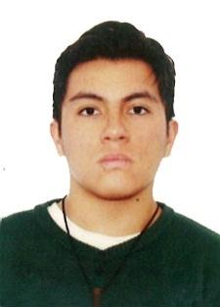
ADDRESS: 59 Woodland st Manchester. 06042
EMAIL:jojo.gozalo8@gmail.com
PHONE: 8608408901
DGAC LICENSE: 6749
APPLIED STUDIES:

SCHOOL: SAINT JOSEPH (2002- 2013)

UNIVERSITY: ELMER FAUCETT AERONAUTICAL TECHNICAL UNIVERSITY
(AERONAUTICAL MAINTENANCE JUN 2014 –JAN 2017)

LANGUAGES: ADVANCED ENGLISH

PRE PROFESSIONAL PRACTICES:
O.M.A N° 053 “LIB MANDY”
-MAINTENANCE PRACTITIONER
(DECEMBER 2016- MARCH 2017)
WORK EXPERIENCE
*O.M.A N° 053 “LIB MANDY” MASTERS OF THE SKY
-AERONAUTICAL MAINTENANCE TECHNICIAN
(MARCH 2017-DECEMBER 2019)
reason for departure: pandemic
*LATAM AIRLINES BY KONECTA
COSTUMER SERVICE
(JUNE 2021- SEPTEMBER 2022)
Reason for leaving: change of residence
*TRADER JOE WAREHOUSE
-DRY OFFLOADER
(DECEMBER 2022- SEPTEMBER 2023)
Reason for leaving: best job offer
*TACOBELL
- CASHIER
(SEPTEMBER 2023- CURRENTLY WORKING)

PERSONAL REFERENCES:
ALFREDO NARRO GARCIA: +51998313643
ERICK COLCA RODRIGUEZ: +51996717567/+51989539054
ANDERSOSN HUAMAN: +51944447286
ADRIANA ZUÑIGA: (203) 8739255
HARDICK DAVE: (419) 8190684

