Ma’am/Sir,
I am writing to express my sincere interest in the Ground Support Equipment Mechanic position at your esteemed company. With over five years of hands-on experience in the aviation industry, I am confident that my expertise in maintenance and repair, along with my dedication to continuous improvement, would allow me to contribute effectively to your team and the continued success of your organization.
Throughout my career, I have developed a comprehensive skill set in the installation, maintenance, and repair of ground support equipment, with a particular emphasis on troubleshooting and ensuring the functionality of aviation systems. I have had the privilege of working with a wide range of ground handling machinery, which has honed my technical abilities and attention to detail. My role has also afforded me the opportunity to work closely with cross-functional teams, ensuring that all equipment is maintained to the highest standards of safety and operational efficiency.
I pride myself on being both organized and proactive, with a strong ability to manage multiple tasks simultaneously while adhering to strict timelines. My hands-on experience combined with my ability to work well independently and in team-oriented environments, positions me as a reliable and adaptable professional who thrives in fast-paced settings. Additionally, I have a strong desire to continue learning and evolving within the field, as I understand the importance of staying updated with the latest technologies and industry standards.
I am confident that my technical expertise, professional demeanor, and commitment to excellence make me an ideal candidate for the Ground Support Equipment Mechanic role at your company. I would welcome the opportunity to discuss how my qualifications align with your team's needs and how I can contribute to your company’s success.
Please find my resume attached for your review. I would be honored to speak with you further about my qualifications and how I can add value to your organization. Thank you for considering my application, and I look forward to the opportunity to discuss this exciting opportunity with you.
Sincerely,
Patrick Novie Bryan A. Rivera
Applicant
PATRICK NOVIE BRYAN ALZADON RIVERA
Aircraft Mechanic

CONTACT DETAILS

# 48 Brgy. Aranguren, Capas, Tarlac, 2315
Contact Number: 0950–2403–713
bryanalzadonrivera@gmail.com

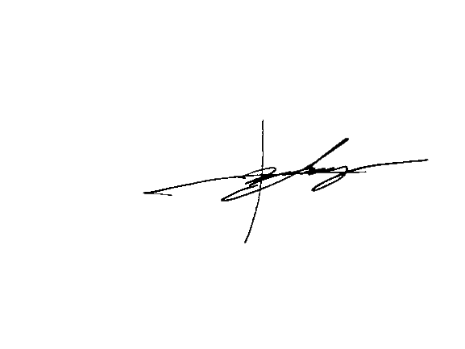


PATRICK NOVIE BRYANALZADONRIVERA
Aircraft Mechanic

OBJECTIVE
Pursuing an opportunity which will allow me to grow professionally and to succeed in a stimulating and challenging environment, building the success of the company while I experience advancement opportunities.
CONTACT DETAILS

#48 Aranguren, Capas, Tarlac, 2315
Contact Number: 0950–2403–713
bryanalzadonrivera@gmail.com

PERSONAL INFORMATION

Sex: Male
Age: 27 years old
Civil Status: Single
Date of Birth: November 10, 1997
Place of Birth: Concepcion, Tarlac
Weight: 80 kg.
Height: 5’9
Nationality: Filipino
Religion: Roman Catholic
Languages: English and Filipino
PROFESSIONAL SUMMARY
Aircraft Mechanic with over five years of experience in aircraft maintenance, repair, and troubleshooting. Skilled in ground handling, routine inspections, and ensuring all systems meet safety and regulatory standards. Experienced in working with mechanical and electrical systems. Reliable, detail-oriented, and able to work effectively under pressure.

WORK EXPERIENCE
- DNATA
Clark International Airport, Andres Bonifacio Avenue, Clark Freeport Zone, 2023 Pampanga, Philippines
Position: Team Lead GSE Mechanic
Duration: August 01, 2022 - March, 2025
Duties and Responsibilities:
- Inspects ground support equipment to determine whether repairs are needed.
- Repairs various systems that are found on pieces of heavy equipment.
- TRANSNATIONAL AVIATION SUPPORT SERVICE
Clark International Airport, Andres Bonifacio Avenue,
Clark Freeport Zone, 2023
Pampanga, Philippines
Position: Ground Support Equipment Mechanic
Duration: May 23, 2019 – March 12, 2020
Duties and Responsibilities:
- Inspects ground support equipment to determine whether repairs are needed.
- Repairs various systems that are found on pieces of heavy equipment.
- OJT at APG International Aviation Academy Inc.
Bldg. 8313 Midway Apron, Subic Bay International Airport SBMA Olongapo City
Position: Intern
Duration: June 01,2017 to December 18,2017

EDUCATION
Holder of Shielded Arc Welding NC1 and NC2 Certificate.
Tertiary: Aircraft Mechanic
APG International Aviation Academy
Dau, Mabalacat City, Pampanga
Year Graduated: 2017

SKILLS
- Aircraft maintenance
- Troubleshooting skills
- Repair Experience
- Safety protocols
- Team management

CHARACTER REFERENCES
Mr. Joel B. Fabello
OIC of APG International Aviation Academy
Mobile No.: +639332980612

Mr. Melvin C Balala
DNATA GSE Mechanic
Mobile No.: +639515511847

Hereby certified that all written above is true and correct to the best of my knowledge.

APPLICANT’S SIGNATURE

