C
CURRICULUM VITAE
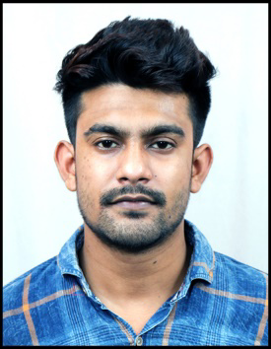

CHHOTON DAS

CONTACT NO- 9609547333
EMAIL ID- Chhoton.das7333@gmail.com

ADDRESS :-

VILL+P.O- DAFAHAT,
P.S- SUTI,
DIST- MURSHIDABAD,
PIN- 742224

PROFILE
- Diploma in MECHANICAL ENGINEERING with a keen aptitude for learning and productively applying new knowledge resourcefully.
- Sincere, dependable and highly organized individual.
An effective communicator with strong analytical & problem solving skills.
- Quick learner and flexible in shifting to different domains.

EDUCATIONAL QUALIFICATIONS

DEGREE | BOARD/  UNIVERSITY | COLLEGE/SCHOOL | YEAR | PERCENTAGE
Diploma (M.E) | W.B.S.C.T.E | JAKIR  HOSSAIN INSTITUTE  OF POLYTECHNIC | 2017 | OVERALL PERCENTAGE OF MARKS – 76.5%
  1 | 2 | 3 | 4 | 5 | 6
  79.2% | 84.8% | 71.6% | 73.3% | 71.6% | 79.5%
Higher Secondary | W.B.C.H.S.E | N.G.D.I | 2013 | 62%
Secondary | W.B.B.S.E | N.G.D.I | 2011 | 60.13%

TECHNICAL EXPERIENCES

NAME OF THE ORGANISATION | DESIGNATION | DATE
MUKESH TRAINING ACADEMY (MUKESH HYUNDAI) | INDUSTRIAL TRAINEE | 06.08.2016 TO 06.09.2016
TAKATA INDIA PRIVATE LIMITED | OPERATING ENGINEER TRAINEE | 04.08.2017 TO 28.09.2018
AIRPORTS AUTHORITY OF INDIA, NSCBI AIRPORT, KOLKATA | TECHNICIAN APPRENTICE (MOTOR TRANSPORT SECTION) | 12.04.2019 TO 11.04.2020
SAI AVIOTECHNICS (AMRITSAR AIRPORT) | TECHNICIAN | 01.10.2020 TO 20.10.2021
ANLON TECHNOLOGY SOLUTIONS LTD. (GUWAHATI AIRPORT) | TECHNICIAN AT (AIRPORT RESCUE AND FIRE FIGHTER) | 01.11.2021 TO PRESENT

PERSONAL DETAILS

Name : Chhoton Das
Father’s Name : Anup Kumar Das
Mother’s Name : Jonaki Das
Date of Birth : 13/08/1995
Languages known : Bengali, English, Hindi
Sex : Male
Nationality : Indian
Religion : Hindu
Marital status : Single
Hobbies : Internet surfing, Driving.

I hereby declare that the above mentioned information is true to the best of my knowledge and
belief and I bear the responsibility for the correctness of the above mentioned particulars.

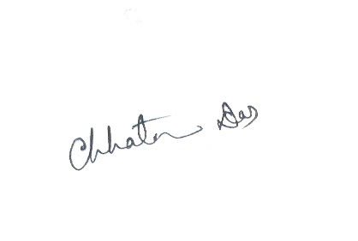
Date:
Signature
Place: GUWAHATI

