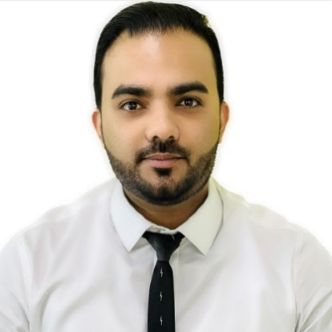
MOOSA SUNAIF
+971 52 9191 735 | moosasunaif@gmail.com
Dubai, United Arab Emirates

PROFILE

A pro-active and enthusiastic Mechanical Engineer with outstanding communication skills and proven track record in Sales &Procurement; capable of working on own initiative or as part of a team with excellent analytical and problem-solving skills. Sets high standard of quality in any task undertaken and contributes total commitment and dedication to achieve those objectives.

PROFESSIONAL EXPERIENCE

Key Account Manager|

Jebel Ali Free Zone, Dubai, UAE
April 2011 – Present

PROGRAM IEBS & Microsoft Dynamics AX
KEY ACCOUNTS McDermott, Petromasila, Calvalley, Safer Exploration, Lamprell,
Oman LNG, Saipem, Baker Hughes, DUGAS, DUCAB, EGA, etc.
PRODUCTS Grainger Industrial Supplies, Pipes, Valves & Fittings, Material Handling Equipment’s, Power Generators, Hoses, Pumps and Motors etc.

ACHIEVEMENTS:
- Consistently achieved more than Ten Million Aed sales targets per annum for past 5 years.
- Achieved 44%, quote to sales conversion ratio against 22.5% set target.
- Introduced & maintained more than 60 clients.
- Executed Project orders for UAE, OMAN & YEMEN Regions worth Million Dollars.
- Achieved Yearly KPI of attaining / Improving credit terms with supplier and customers.
- Negotiated rates, payment, delivery and logistic terms in key deals resulting in enhanced profits in the range of 20-30%.
- Nominated Internal ISO auditor.

Sales & Business Development – Industrial Materials, Oil & Gas Supply, and Heavy Machineries
- Generate project inquiries from foreign& local traders, EPC contractors & End Users.
- Provide technical, functional and subject matter expertise to our sales team.
- Be a lead resource in Preparing estimation, costing, pricing, and technical-commercial quotations for Local & Foreign customers.
- Create market reports through research to analyze new project opportunities.
- Establishes and exploits good, mutually beneficial relationships with customers and other key institutions to secure the orders.
- Take ownership of all aspects related to the execution of orders & payment collection.
- Maintained a real time order status report to monitor delivery of all active orders.
- Actively participate as a subject matter expert at industry conferences, tradeshows, customer events and summits providing technical presentations and product demonstrations.
- Provide coaching and professional development to team members, sales associates in order to enhance their product knowledge, technical acumen, and technical sales skills.
- Guide Procurement team on supplier details, Target Pricing and negotiations.
- Provide accurate and punctual forecasting report on monthly basis to the Management along with maintaining Reports as per ISO 9001 standard.
Production & QHSE Engineer| Mika Industries, India
August 2010 – March 2011
- Research and Development- assessing new products and innovations and building prototypes using computer aided design (CADD) and computer modeling programs.
- Supervise day-to-day activities & Quality health and safety standards in the Machinery Mill in the utmost effective manner and proper guidance.
- Review documents and work quality in terms of specification, workmanship and other variables as indicated in the documents as per requirements of QC standard operating procedure.

ACADEMIC BACKGROUND& SKILLS
BE in Mechanical Engineering| India
Visvesvaraya Technological University
Completed in 2010

NEBOSH Certification UK| India
Arbrit Safety and Engineering Solutions Ltd
Health and Safety Practical application, Management of International Health and Safety,
Control of International Workplace Hazards. Completed in 2010

Diploma in AutoCAD 2D| India CADD Centre .Completed in 2010

ACHIEVEMENTS &ACCOLADES
Awarded Best Salesperson Multiple Times.
2010 - Engineering Project on Pneumatic Material Handling Equipment
2011 - Awarded as Best New Comer of the Year.

INTERESTS
Sports & Outdoor activities.
Travelling.
Prominent role in theatre in school and college.

PERSONAL DETAILS

Date of Birth: 5 September 1988
Nationality: Indian
Marital Status: Married
Languages: English, Hindi, Malayalam, Kannada, Tamil
Driving License: UAE (1773785)
Visa Status: UAE Resident Visa (Free Zone)

* References will be furnished on demand.

