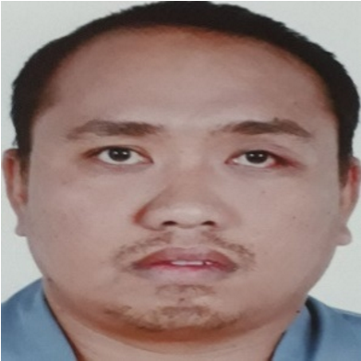
- To work towards providing better service to customer in the field of air conditioning maintenance.
JEFFREY SUAREZ CASTRO
EMAIL ADDRESS:
tabuse666@gmail.com
ADDRESS:Mina Subdivision,Calaylayan, Abucay, Bataan, Philippines
PHONE NUMBER : 0545525736
CARREER OBJECTIVES
:
➢ To obtain a GSE TECHNICIAN position in an organization with the potential to expand and grow.`
KEY SKILLS:
- Skills in operating all types of power and hand tools safely and effectively.
- Good exposure in installing, maintaining, and repairing air conditioners.
- Analytical approach to work.
- Good communication skills with a positive attitude toward work.
- Thorough with the servicing procedure of AC testing system for proper functioning.
- Knowledge in repairing and servicing of ground support equipment.
EDUCATIONAL QUALIFICATION:
VOCATIONAL : Major In Refrigeration and Airconditioning Technology School Year 2002-2004
WORK EXPERIENCES:

➢ Genesis Transport Service, INC. (New York Street, Cubao, Quezon City)
- Description of Work: BUS AIRCON TECHNICIAN
- Duration: May 2008 – June 2014
- Responsibilities: PERFORMS ALL MAINTENANCE SUCH AS
REPAIRING, CLEANING, AND TROUBLESHOOTING ISSUES ON THE BUS AIR CONDITIONING UNIT.

➢ Saneha Trading Est. (Riyadh, Saudi Arabia)
- Description of Work: AUTO AIRCON TECHNICIAN
- Duration: June 2014 - March 23, 2016
- Responsibilities: PERFORMS ALL MAINTENANCE SUCH AS REPAIRING, CLEANING TROUBLESHOOTING ISSUES ON LIGHT, AND HEAVY VEHICLES/EQUIPMENT.

➢ EL KHEREIJE COMPANY (SAUDIA AIRLINES) (JEDDAH,SAUDI ARABIA)
- DESCRIPTION OF WORK: GROUND SUPPORT EQUIPMENT MAINTENANCE
- DURATION: MAY 05, 2017- JUNE 30,2021

RESPONSIBILITIES:
.PERFORMED ALL MAINTENANCE SUCH AS CLEANING, TROUBLESHOOTING
OPERATION ISSUES.
- INSPECTS AND REPAIRED DEFECTIVE GROUND EQUIPMENT
- PERFORMS PLANNED PREVENTIVE AND NON-ROUTINE MAINTENANCE
- PERFORMS DIAGNOSIS FIELD/SHOP REPAIR, ALTERATION MODIFICATION, FUNCTIONAL AND OPERATIONAL TEST OF EQUIPMENT
- USE SHOP MANUALS AND TECHNICAL DRAWINGS & FOLLOW ALL SAFETY PROCEDURES

➢ TLD AES (JEDDAH, SAUDI ARABIA)
- DESCRIPTION OF WORK: GROUND SUPPORT EQUIPMENT MAINTENANCE
- DURATION: JULY 2022 - PRESENT

RESPONSIBILITIES:
- PERFORMED ALL MAINTENANCE SUCH AS CLEANING, TROUBLESHOOTING
OPERATION ISSUES.
- INSPECTS AND REPAIRED DEFECTIVE GROUND EQUIPMENT
- PERFORMS PLANNED PREVENTIVE AND NON-ROUTINE MAINTENANCE
- PERFORMS DIAGNOSIS FIELD/SHOP REPAIR, ALTERATION MODIFICATION, FUNCTIONAL AND OPERATIONAL TEST OF EQUIPMENT
- USE SHOP MANUALS AND TECHNICAL DRAWINGS & FOLLOW ALL SAFETY PROCEDURES

Personal Profile:
Name : | Jeffrey S. Castro
Nationality : | Filipino
Birth Date : | October 8, 1983
Birth Place : | Abucay, Bataan, Philippines
Age : | 39
Sex : | Male
Civil Status : | Married
Height : | 5’7”
Weight :  Personal Reference:  Larry B. Banasing | 90 kgs
Occupation : | GSE Technician
Contact Number : | 0553098145
I hereby solemnly declare that all the information above is true as per my knowledge and belief.
Respectfully yours,
Jeffrey Castro

