RESUME
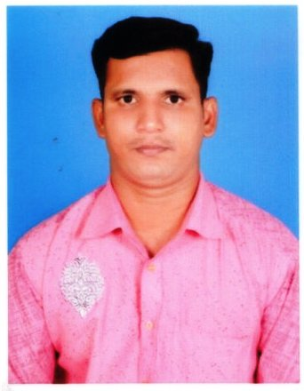
GEORGE JOSEPH .A
S/o Albert Durairajan. S.T
Iswarya Nagar
Near Aircel Tower,
A.K.Nagar,
Lalgudi (TK)
Trichy (DT) – 621 601

E.MailID :samjoens2013@gmail.com
ContactNo : +91 9944125558
OBJECTIVE:
EDUCATIONAL QUALIFICATION :

Utilize my creative ideas for challenging role in the organization for its growth and hence provide scope for widening the spectrum to my knowledge.

HSC : Higher Secondary Class Private,
Lalgudi.
SSLC : Govt. Hr. Sec. School,
Anbil.
EXTRA COURSE:
APPRENTICES :
TECHNICAL QUALIFICATION:

Mechanic : Don Bosco I.T.I – Lalgudi,
Passed in the Year of 2002 - 2004
(Motor vehicle – PETROL AND DIESEL)

- Tamil Nadu State Transport Corporation (Kum) Ltd,Trichy, 2007-2008

- CNC Programming & Training Simulation S.I.T, Trichy.
- Indian Driving Licence LMV, HTVF/TN/48/004600/2004
- Non-Transport Veh Valid 18/10/2024, Transport Veh Valid 18/12/2019
- Basic Computers

EXPERIENCE:

- 2007 to 2009
TNSTC CONTRACT WORK
- 2009 -2012
PRIVATE WORK SHOP – TRICHY( PETROL AND DIESEL)
- 2013 – 2020
BHADRA INTERNATIONAL
INDIA PVT LTD Trichy Airport :
GPU, TLD, Push Back ASU,
Package Electrical Tripple, ACU,
EQUIPMENT ALL SERVICE & MAINTENANCE
- 2021 – 2022 May
AGILE AIRPORT SERVICE PVT. LTD., TRICHY
HEAVY DIRVER
- 2022 TO 2023
SAUDIA GROUND SERVICE – KING ABDULAZIZ INTERNATIONAL AIRPORT – JEDDAH – GSE OPERATOR
–HI. LOADER, TRANSPORT COV. BELT, PASSANGER STEP, BAGGAGE DRIVER.

PERSONAL DETAILS:

Father’s Name : Mr. Albert DuraiRajan. S.T
Date of Birth : 02.06.1986
Gender : Male
Marital Status : Unmarried
Nationality : Indian
Religion : Christian
Languages Known : Tamil, English,

DECLARATION
I hereby declare that the above – furnished information is true and correct to the best of my knowledge and belief.
Place: Signature
Date : (GEORGE JOSEPH .A)

