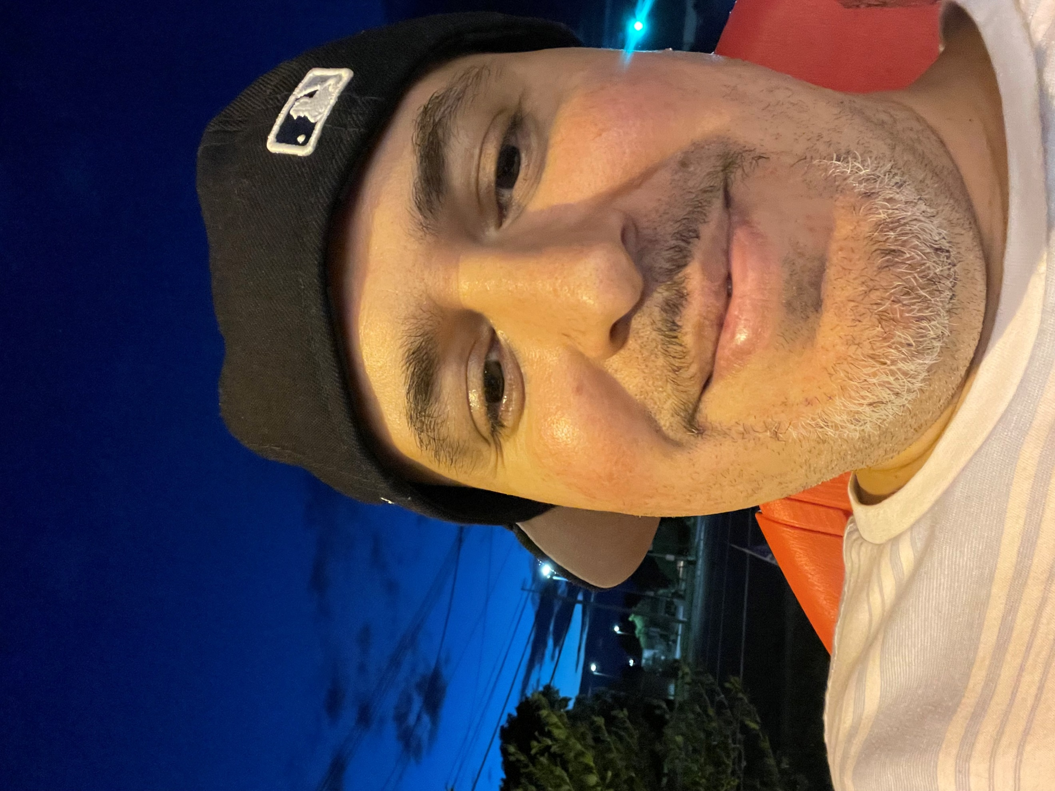  PHONE:  959-234-6550  EMAIL:  Soto.nene.1980@gmail.com  Hobbies  Learning and growing  Puzzles and solving problems |  | EDUCATION  Quinnipiac University- Connecticut  February 2017 – February 2021  Sociology and human Behavior  Vocational Training  April 2004 - 2008  Business Education  WORK EXPERIENCE  FHI Supervisor  October–Present  Overseeing over 50 selectors and multiple coordinators. Monitor their performance and hold them accountable to policy and procedure. Following up on culture and morale. Direct associates to perform operations safely and efficiently. Accountable for successful completion of load assignments. Production hours and completion of tasks to fulfill the operation.  FHI Coordinator  July–October  Overseeing over 25 selectors and pushed the work night in and night out. Account for associate performance Kronos time keeping and hiring and firing.  FHI Reclamation Coordinator  April 3023–July 2023  Ran the whole reclamation 2nd shift and in charge of 10 associates removing debris off trucks and maintaining a clean inbound dock. Worked with ADUSA and YMS moving trailers around the yard on all pads.  SKILLS  Kitchen Experience running teams making sure food is complete.  Communication skills  Fluent in Spanish  Social work Warehouse management YMS  Microsoft Office  Business management  Order picking  Accounting  Teaching and tutoring selectors  Certifications  CPR  Heimlich Maneuver  Business Education  All Power Equipment  Forklift  Double Pallet jack  Pacer  Center Rider  Can certify associates

